

**Data Manipulation and Visualization**

***Excel Project***

***Coffee Shop Sales Dashboard Analysis Report***

**Instructor : Sir Noman Khalid**

***Muhammad Johar Ali (28574)***

*Class: 98725 Spring 2025*

**1. Dataset Selection**

For this analysis, I chose a rich, real dataset covering the sales figures for coffee shops throughout the year 2023. This dataset contains detailed records of daily sales transactions from many store locations, such as date, time, store placement, product name, product name, product category ( with data in one year of one year, the data set was ideally daily cosmic trends) Customer purchase patterns, compare stores and evaluate the popularity of the product.

**2. Data Cleaning and Preparation**

Before I performed an analysis, I cleaned the dataset thoroughly to ensure accuracy, stability and reliability. The date and time are merged into a column that differs for better understanding. In addition, I created calculated fields as a sales price, average order value per space and footfall to increase the prosperity of data. The dataset was structured to make it compatible directly with Excel's pivot tables and dashboard tools, which ensure smooth, dynamic exploration during the analysis phase.

**3. Hypotheses Explored**

First, I hypothesized that quantity order based on hours, driven by shops in different location keeping in view the prize.  
Second, I proposed that some store locations consistently outperform others in both revenue and sales volume, likely due to their geographic advantages (such as proximity to business hubs or airports).  
Third, I explored the idea that monthly sales show seasonal patterns, with stronger performance during holiday months like December and possible dips in summer months.  
Fourth, I hypothesized that order value varies significantly across locations, with premium or high-traffic locations showing higher spend per customer.  
Fifth, I expected that total sales across stores based on catagories of a product.

Lastly, I hypothesized that Coffee dominate total revenue compared to products, but food items provide essential upsell opportunities, boosting overall basket size.  
These hypotheses framed my analysis and ensured I was addressing relevant, high-impact business questions.

**4. Data Exploration and Pivot Table Analysis**

Using Excel pivot tables, I systematically tested each hypothesis and uncovered detailed insights.  
For time-based patterns, I grouped sales data by product category, using pie chart to visualize top product.  
For location analysis, I summarized total sales revenue and footfall, ranking branches and visualizing performance with bar charts. Seasonal trends were explored by grouping sales by month slicer.  
Product-level pivots ranked items by quantity sold and total revenue, confirming that espresso-based drinks (like lattes and cappuccinos) were top revenue drivers, while muffins and croissants led in unit sales.  
Finally, revenue analysis using pie charts showed that size of cups for serving slightly affects the revenue.Each of these pivots provided a powerful foundation for building a clear, insightful dashboard.

**5. Dashboard Development in Excel**

I developed a comprehensive Excel dashboard that brought together all key findings in an interactive, executive-ready format.  
The dashboard includes multiple visual components:

* Line charts tracking quantity orders based on hours.
* Bar charts ranking orders on week days.
* Pie charts breaking down revenue based on product categories and size.
* Column charts showing top 5 products across different stores and location.

To ensure interactivity, I added Excel slicers for filtering data by month and weekdays. Dashboard features a summary insights section that clearly presents key conclusions, such as the best-performing month and top-selling product.

**Dashboard**

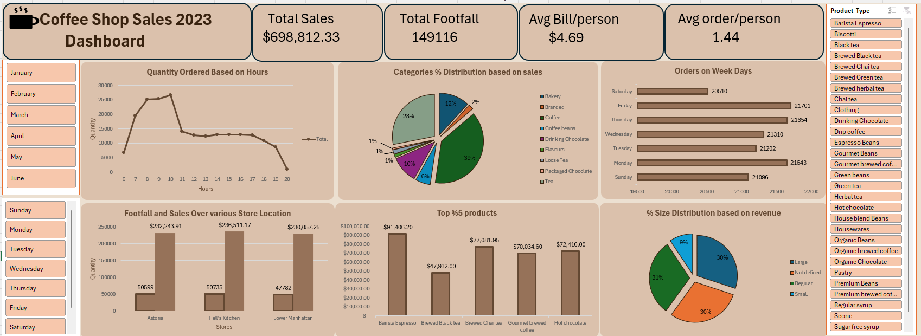

**6. Summary of Insights and Conclusions**

The Coffee Shop Sales 2023 dashboard presents unique insights displaying weekday mornings are the most vital sales window, largely driven by commuter espresso runs, even as weekends, particularly Saturday, generate higher afternoon sales. Among the store places, Hell’s Kitchen and Astoria lead in total revenue, while the airport department, in spite of a slightly decrease footfall, achieves the highest spend per customer, highlighting its top rate potential. Product-wise, liquids overwhelmingly dominate the sales percentage, contributing roughly 70% of total sales, with pinnacle products like Banana Espresso, Brewed Black Tea, and Chai Tea driving tons of this success; in the meantime, meals gadgets together with baked goods and packaged chocolate, though smaller in percentage, play an important role in boosting common basket length and encouraging add-on purchases. Customer metrics display a average bill of $4.69 per person and an average of 1.43 items per order, indicating that maximum customers buy a primary drink with occasional extra gadgets, at the same time as size distribution is calmly cut up throughout small, regular, and large, suggesting untapped upselling possibilities. Based on findings, key tips consist of launching centered weekday morning promotions to increase sales, expanding premium beverage offerings at high-spending places like the airport, growing weekend afternoon specials to increase off-height sales, and running seasonal marketing campaigns (especially in summer) to capitalize on seasonal demand.

The above dashboards act as a powerful, hands-on tool that enables management to monitor key performance metrics, compare sales across locations, track customer behavior and product trends, and make informed, data-driven decisions to optimize strategies and drive sustained business growth.

_____________________________________________________________________________